

Semester Two Examination, 2016

Question/Answer Booklet

MATHEMATICS

SOLUTIONS
METHODS
UNITS 1 AND 2

Section One:

Calculator-free

Student Number: In figures

In words

Your name

Time allowed for this section
Reading time before commencing work: five minutes
Working time for section: fifty minutes

Materials required/recommended for this section
To be provided by the supervisor
This Question/Answer Booklet
Formula Sheet

To be provided by the candidate
Standard items: pens (blue/black preferred), pencils (including coloured), sharpener, correction fluid/tape, eraser, ruler, highlighters

Special items: nil

Important note to candidates
No other items may be taken into the examination room. It is your responsibility to ensure that you do not have any unauthorised notes or other items of a non-personal nature in the examination room. If you have any unauthorised material with you, hand it to the supervisor before reading any further.

Structure of this paper

Section | Number of questions available | Number of questions to be answered | Working  time (minutes) | Marks available | Percentage of exam
Section One:  Calculator-free | 8 | 8 | 50 | 52 | 35
Section Two:  Calculator-assumed | 12 | 12 | 100 | 98 | 65
 |  |  | Total | 150 | 100

Instructions to candidates

1. The rules for the conduct of examinations are detailed in the school handbook. Sitting this examination implies that you agree to abide by these rules.

2. Write your answers in this Question/Answer Booklet.

3. You must be careful to confine your response to the specific question asked and to follow any instructions that are specified to a particular question.

4. Spare pages are included at the end of this booklet. They can be used for planning your responses and/or as additional space if required to continue an answer.
- Planning: If you use the spare pages for planning, indicate this clearly at the top of the page.
- Continuing an answer: If you need to use the space to continue an answer, indicate in the original answer space where the answer is continued, i.e. give the page number. Fill in the number of the question that you are continuing to answer at the top of the page.

5. Show all your working clearly. Your working should be in sufficient detail to allow your answers to be checked readily and for marks to be awarded for reasoning. Incorrect answers given without supporting reasoning cannot be allocated any marks. For any question or part question worth more than two marks, valid working or justification is required to receive full marks. If you repeat any question, ensure that you cancel the answer you do not wish to have marked.

6. It is recommended that you do not use pencil, except in diagrams.

7. The Formula Sheet is not to be handed in with your Question/Booklet.

Section One: Calculator-free 35% (52 Marks)
This section has eight (8) questions. Answer all questions. Write your answers in the spaces provided.

Working time for this section is 50 minutes.

Question 1 (4 marks)
A box contains a total of 500 marker and highlighter pens of various colours, as shown in the table. Some of the marker pens are permanent and the rest are non-permanent.
 | Colour
Type of pen | Black | Yellow | Pink | Green
Permanent marker | 55 | 83 | 40 | 24
Non-permanent marker | 45 | 67 | 24 | 12
Highlighter | 0 | 50 | 46 | 54

A pen is selected at random from the box. Determine the probability that it is

(a) a yellow pen. (1 mark)
Solution
$$\frac{83+67+50}{500}=\frac{200}{500}=\frac{2}{5}$$

Specific behaviours
correct probability

(b) a marker pen. (1 mark)
Solution
$$\frac{500-\left(50+46+54\right)}{500}=\frac{350}{500}=\frac{7}{10}$$

Specific behaviours
correct probability

(c) a yellow pen or a marker pen. (1 mark)
Solution
$$\frac{200+350-83-67}{500}=\frac{400}{500}=\frac{4}{5}$$

Specific behaviours
correct probability

(d) a green pen, given that it is a highlighter. (1 mark)
Solution
$$\frac{54}{50+46+54}=\frac{54}{150}=\frac{9}{25} (=0.36)$$

Specific behaviours
correct probability

Question 2 (6 marks)
(a) Determine $f'(x)$ when $f\left(x\right)={\left(x-5\right)}^{2}$. (2 marks)
Solution
$$f\left(x\right)=\left(x-5\right)\left(x-5\right)=x^{2}-10x+25 \\ f^{'}\left(x\right)=2x-10$$

Specific behaviours
expands
differentiates

(b) Simplify

(i) $\frac{d}{dx}\left(5x^{2}-4x+3\right)$. (1 mark)
Solution
$$10x-4$$

Specific behaviours
differentiates all terms

(ii) $\lim_{h→0}{\frac{{\left(x+h\right)}^{4}-x^{4}}{h}}$. (1 mark)

Solution
$$\frac{d}{dx}x^{4}=4x^{3}$$

Specific behaviours
differentiates

(c) Calculate the gradient of the curve $y=2x^{5}-3x^{4}$ where $x=-1$. (2 marks)
Solution
$$\frac{dy}{dx}=10x^{4}-12x^{3} \\ \frac{dy}{dx}=10+12=22$$

Specific behaviours
differentiates
substitutes and simplifies

Question 3 (8 marks)
(a) The equations $x^{3}+x^{2}+ax+b=0$ and $x^{3}-bx^{2}-ax+4=0$ both have $x=2$ as a solution. Determine the values of $a$ and $b$. (4 marks)
Solution
$$8+4+2a+b=0⇒2a+b=-12 …(1) \\ 8-4b-2a+4=0⇒4b+2a=-12 …(2) \\ \left(2\right)-\left(1\right): 3b=24⇒b=8 \\ \left(1\right):2a+8=-12⇒a=-10$$

Specific behaviours
substitute and simplify first equation
substitute and simplify second equation
solve for first variable
solve for second variable

(b) The equation $x^{3}-x^{2}-14x+24=0$ also has $x=2$ as a solution. Determine all other solutions to the equation. (4 marks)
Solution
$$x^{3}-x^{2}-14x+24=\left(x-2\right)\left(x^{2}+cx-12\right) \\ \text{Consider} x \text{coefficient}: -14=-2c-12⇒c=1 \\ x^{2}+x-12=\left(x+4\right)\left(x-3\right) \\ \text{Other solutions are} x=-4 \text{and} x=3$$

Specific behaviours
uses $(x-2)$ to start factorisation
obtains quadratic factor
factorises quadratic
states other two solutions

Question 4 (6 marks)
(a) $A$ and $B$ are independent events such that $P\left(A\right)=\frac{2}{3}$ and $P\left(B\right)=\frac{1}{4}$. Determine

(i) $P(A∩B)$. (1 mark)
Solution
$$\frac{2}{3}×\frac{1}{4}=\frac{1}{6}$$

Specific behaviours
calculates probability

(ii) $P(B|A)$. (1 mark)
Solution
$$\frac{1}{4}$$

Specific behaviours
writes $P(B)$

(iii) $P(A∪B)$. (2 marks)
Solution
$$\frac{2}{3}+\frac{1}{4}-\frac{1}{6}=\frac{8+3-2}{12}=\frac{9}{12}=\frac{3}{4}$$

Specific behaviours
uses probability law
calculates probability

(b) A number is selected at random from the set of positive integers. Event $P$ occurs when the number is odd, event $Q$ occurs when the number is a multiple of five and event $R$ occurs when the number is a perfect square. Determine the smallest number that belongs to the following sets:

(i) $\overline{P}∩(Q∪R)$. (1 mark)
Solution
Even and either MF or PS: 4

Specific behaviours
writes number

(ii) $\overline{P}∩Q∩R$. (1 mark)
Solution
Even and MF and PS: 100

Specific behaviours
writes number

Question 5 (9 marks)
Solve the following equations for $x$:

(a) ${\left(x-11\right)}^{2}-49=0$. (2 marks)
Solution
$$x-11=±7 \\ x=4, 18$$

Specific behaviours
adjusts equation and takes square root
states both solutions

(b) ${27}^{x+1}=9^{1-x}$. (3 marks)
Solution
$$3^{3\left(x+1\right)}=3^{2\left(1-x\right)} \\ 3x+3=2-2x \\ x=-\frac{1}{5}$$

Specific behaviours
writes both sides as powers of 3
equates indices
solves

(c) $\sin^{2}{x}-\cos^{2}{x}=\frac{1}{2}, 0≤x≤360°$. (4 marks)
Solution
$$\sin^{2}{x}-(1-\sin^{2}{x})=\frac{1}{2} \\ \sin^{2}{x}=\frac{3}{4} \\ \sin{x}=\frac{\sqrt{3}}{2}⇒x=60, 120 \\ \sin{x}=-\frac{\sqrt{3}}{2}⇒x=240, 300 \\ x=60°, 120°, 240°, 300°$$

Specific behaviours
uses Pythagorean identity and simplifies
shows two possible values for $\sin{x}$
determines first two solutions
determines another two solutions

Question 6 (5 marks)
(a) The expression ${\left(2x-1\right)}^{3}$ can be expanded to give $8x^{3}+ax^{2}+6x-1$. Show that the value of $a$ is $-12$. (2 marks)
Solution
$${\left(2x-1\right)}^{3}=\left(\begin{matrix}3 \\ 3\end{matrix}\right){\left(2x\right)}^{3}{\left(-1\right)}^{0}+\left(\begin{matrix}3 \\ 2\end{matrix}\right){\left(2x\right)}^{2}{\left(-1\right)}^{1}+… \\ =8x^{3}+3×4x^{2}×\left(-1\right)+… \\ a=3×4×-1=-12$$

Specific behaviours
shows expansion
shows how $x^{2}$ coefficient derived
NB if expands correctly into quadratic, etc

(b) Using the result from (a), or otherwise, determine $f(x)$ if $f^{'}\left(x\right)={\left(2x-1\right)}^{3}$ and $f\left(1\right)=5$.
(3 marks)
Solution
$$f\left(x\right)=\frac{8x^{4}}{4}-\frac{12x^{3}}{3}+\frac{6x^{2}}{2}-x+c \\ =2x^{4}-4x^{3}+3x^{2}-x+c \\ f\left(1\right)=2-4+3-1+c=5 \\ c=5 \\ f(x)=2x^{4}-4x^{3}+3x^{2}-x+5$$

Specific behaviours
antidifferentiates
substitutes $x=1$
evaluates $c$ and clearly writes $f(x)$

Question 7 (7 marks)
The first three terms, in order, of geometric sequence are $x-5$, $x-1$ and $2x+4$.

(a) Explain why $\left(x-1\right)\left(x-1\right)=(x-5)(2x+4)$. (2 marks)
Solution
$$\text{Ratio of terms:} r=\frac{T_{2}}{T_{1}}=\frac{T_{3}}{T_{2}}⇒\frac{x-1}{x-5}=\frac{2x+4}{x-1}$$
$$\text{Cross multiply:}{ \left(x-1\right)}^{2}=\left(x-5\right)\left(2x+4\right)$$

Specific behaviours
uses ratio of terms
uses cross multiplication

(b) Determine the value(s) of $x$. (3 marks)
Solution
$$x^{2}-2x+1=2x^{2}-6x-20 \\ 0=x^{2}-4x-21 \\ \left(x-7\right)\left(x+3\right)=0 \\ x=7, -3$$

Specific behaviours
expands both sides
re-arranges equal to zero
factorises and states both solutions

(c) Determine all possible values for the fourth term of the sequence. (2 marks)

Solution
$$x=7, \text{terms are }2, 6, 18, 18×3=54$$
$$x=-3, \text{terms are}-8, -4, -2, -2×\frac{1}{2}=-1$$
$$\text{Fourth term is either }54 \text{or}-1$$

Specific behaviours
determines first possibility
determines second possibility

Question 8 (7 marks)
Let $f\left(x\right)=\frac{1}{x+1}$, $x≠-1$.

(a) Sketch the graph of $y=f(x)$ on the axes below. (3 marks)

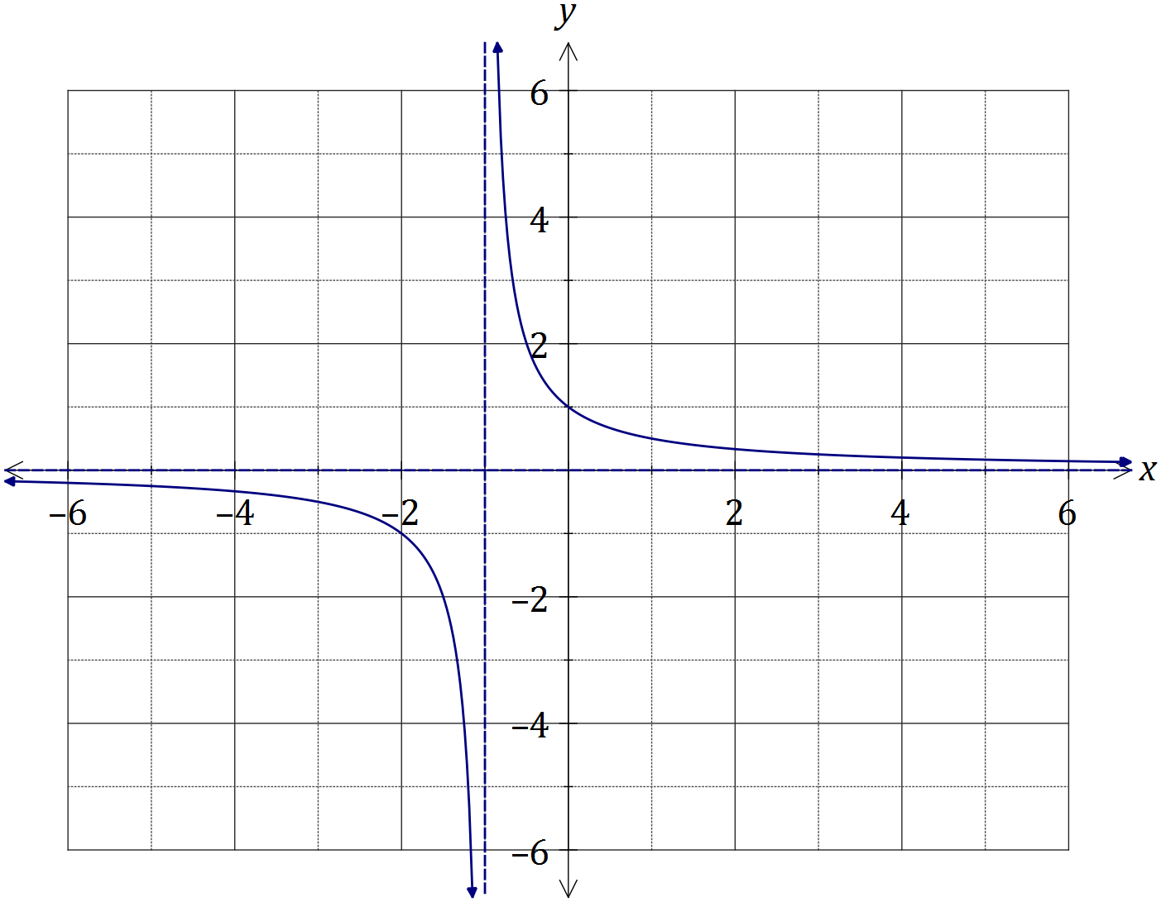
Solution
See graph
Specific behaviours
both asymptotes clear
passes through (-2, -1) and (0, 1)
smooth curve, no 'hooking'

(b) Evaluate the difference quotient $\frac{f\left(x+h\right)-f(x)}{h}$ as $h→0$ to determine the slope of $f(x)$ when $x=2$. (4 marks)
Solution
$$m=\frac{\frac{1}{x+h+1}-\frac{1}{x+1}}{h} \text{with} x=2$$
$$=\frac{\frac{1}{2+h+1}-\frac{1}{2+1}}{h}=\frac{\frac{1}{3+h}-\frac{1}{3}}{h} \\ =\frac{3-3-h}{h×3(3+h)} \\ =\frac{-1}{9+3h} \\ =-\frac{1}{9} \text{as} h→0$$

Specific behaviours
substitutes and simplifies quotient
adds fractions in numerator and simplifies
cancels $h$ in quotient
substitutes $h=0$ to obtain slope

Additional working space

Question number: _________

© 2016 WA Exam Papers. Kennedy Baptist College has a non-exclusive licence to copy and communicate this paper for non-commercial, educational use within the school. No other copying, communication or use is permitted without the express written permission of WA Exam Papers.

